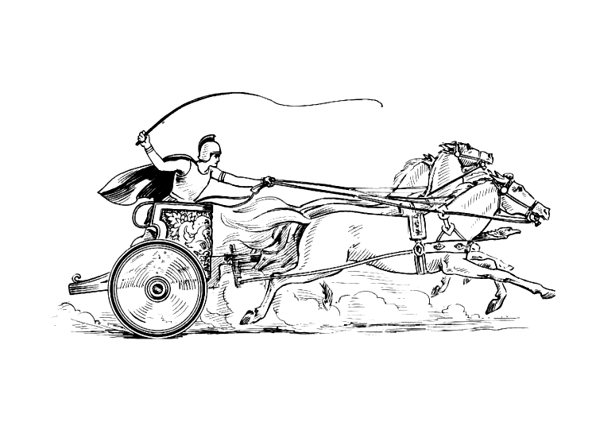MANCETTER PARISH COUNCIL

You are invited to the Annual Parish Meeting
to be held in the schoolroom of St Peter’s Church Mancetter
on Tuesday 29th April 2025 at 7pm
AGENDA

- Welcome and Apologies
- Minutes of the last meeting
a) To receive the minutes of the Annual Parish Meeting of 23rd April 2024
b) Matters arising from the Annual Parish Meeting of 23rd April 2024

- HISTORY AND HERITAGE (Our Past)
Distribution of Parish Council VE 80th Anniversary badges, re-issue of sweet rations with an opportunity to purchase additional sweets for a donation to the Royal British Legion.

- Parish Council Information (Our Present)

- Chairman’s Report
- Financial Officer’s Report
- Planning Applications and Cemetery Changes.

- Opportunity for Feedback from local Organisations and Community Groups.

St Peter’s Church / Roman Mancetter Exhibition
Mancetter Community Panel
Gramer Cottages
Mancetter Memorial Hall Committee
Mancetter W.I. and Ridge Lane “Bluebelles”
Atherstone District Brownies and Guides
Mancetter Scout Group
Ridge Lane Chapel and Community Room.

- Creating the Mancetter Parish of the Future ( Our Vision – Save our E.A.R.T.H.)
“Environment, Amenities, Recreation, Tourism and Heritage”

- What do we need in our communities - Revising our Neighbourhood Plan to reflect our identity and vision for the future.
- Mancetter Nature Reserve interconnected to Hartshill Hayes.
- Tourism and Business Opportunities.

- Discussion on Any Other Parish Business

- Date of Next Parishioners Meeting –
Wednesday 17th September 2025 7pm at Ridge Lane Chapel

Trevor Hopkins Chairman
Parish Office Mancetter Memorial Hall Old Farm Road Mancetter, CV9 1QN
Tel: 01827 722552. Email: parishclerk@mancetterparishcouncil.gov.uk

